**Company Overview**

KombiNed Food Trucks is a specialized company focused on transforming vintage Volkswagen vans into fully electric, sustainable food trucks. Our unique selling proposition lies in blending nostalgia with practicality and modern green technology. We aim to target the European food truck market, which is growing, especially in urban centers and tourist locations.

Our food trucks are available in a wide range of configurations, tailored to fit both your needs and your budget. At the most basic level, we offer professionally renovated, fully designed and decorated vintage Volkswagen food trucks without (major) interior installations, leaving you the freedom to place your own equipment inside. On the other end of the spectrum, our most elaborate models are delivered turnkey, with all appliances, design elements, and client-specific preferences already installed and ready for immediate use.

For those looking to stand out even further, we also provide the option of equipping your classic VW food truck with a fully electric battery package, making it entirely free from fossil fuels. This not only gives you a powerful unique selling point in positioning yourself as the most sustainable type of food truck imaginable, but it also opens doors to an increasingly exclusive clientele.

This way, your retrofitted electric VW food truck will not only bring a vintage aesthetic but will also be fully compliant with the latest European Union emission regulations, allowing them to operate in Zero and Low Emission Zones.

**Mission Statement**

Our mission is to *preserve* the classic beauty of Volkswagen T1 and T2 vans while offering an innovative solution for the food and beverage industry that reduces carbon emissions, meets future regulatory standards, and delivers a unique and nostalgic experience for customers.

**What types of trucks do we specialize in?**

• **Coffee Barista Truck** – A mobile café with professional barista equipment, serving espresso, lattes, and specialty brews.

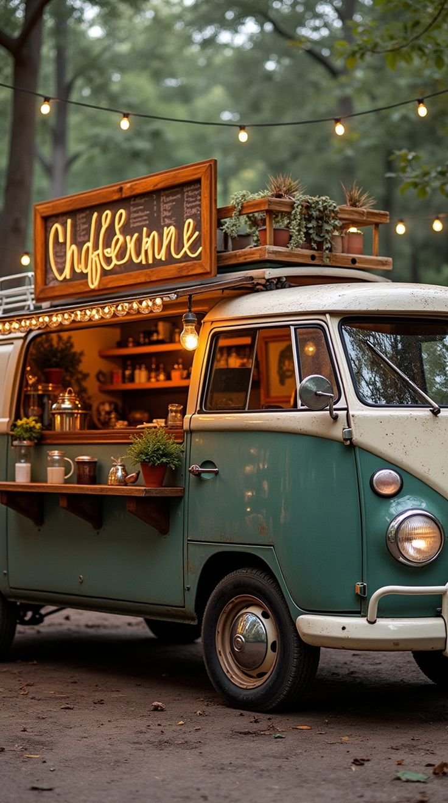

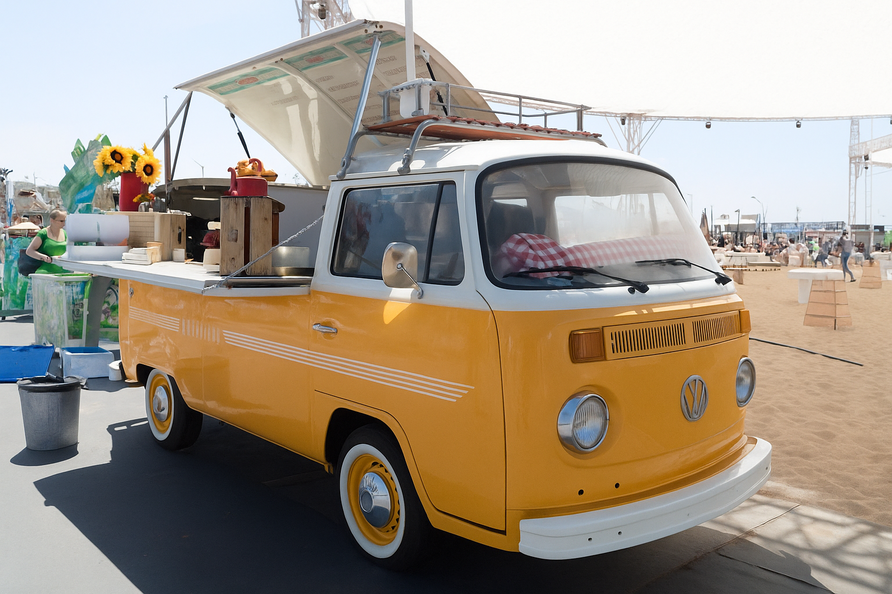

• **Cocktail Truck** – A fully equipped mobile bar serving craft cocktails and premium drinks, perfect for events and celebrations.

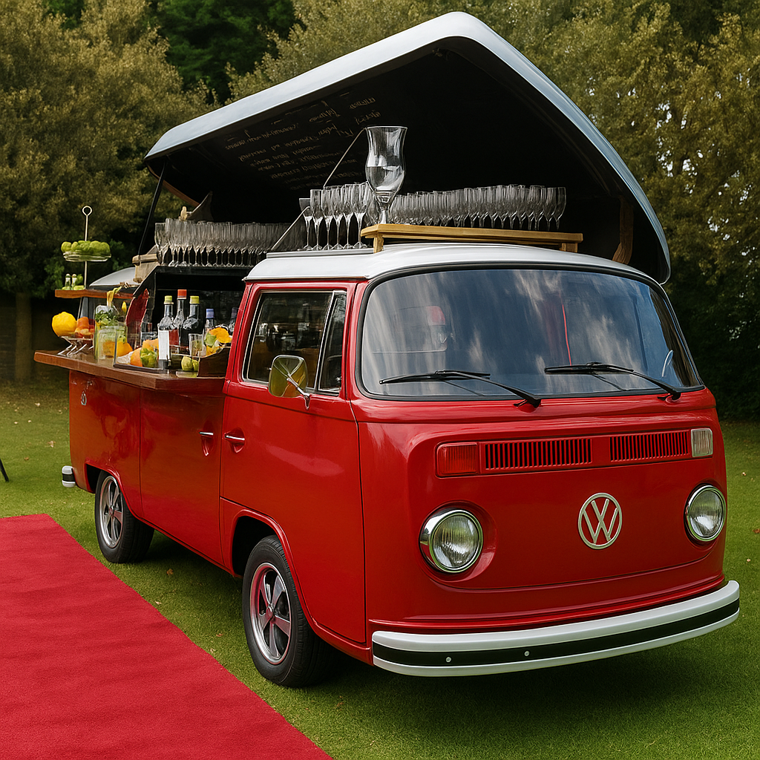

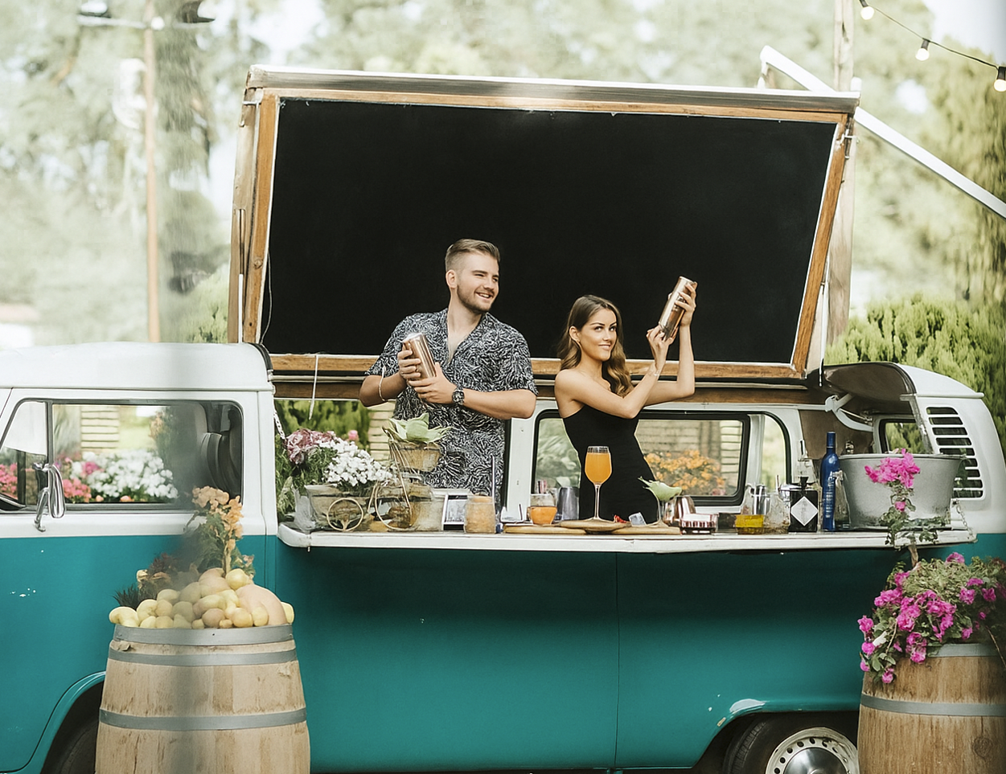

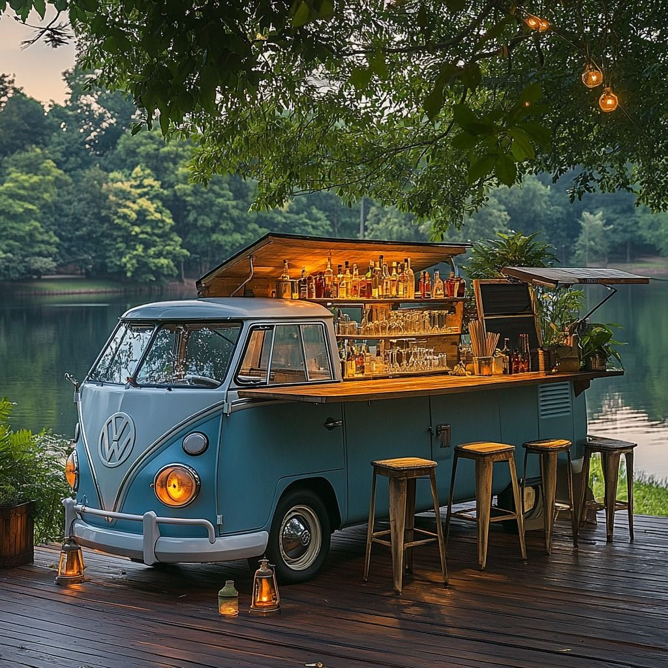

• **Smoothie Truck** – A refreshing station offering healthy smoothies, juices, and fresh fruit blends on the go.

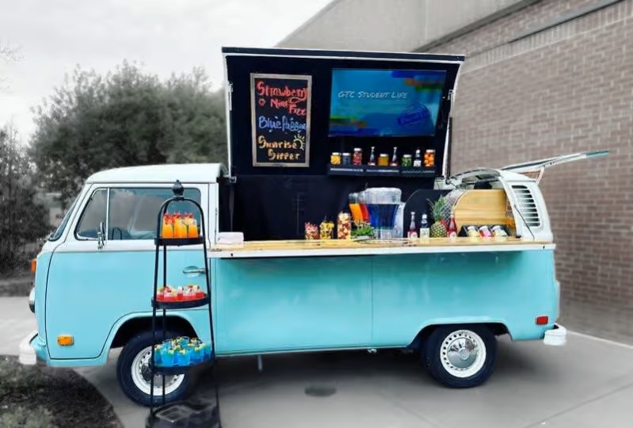

• **Ice Cream Truck** – A nostalgic yet modern truck serving classic ice creams, gelato, or frozen treats for all ages.

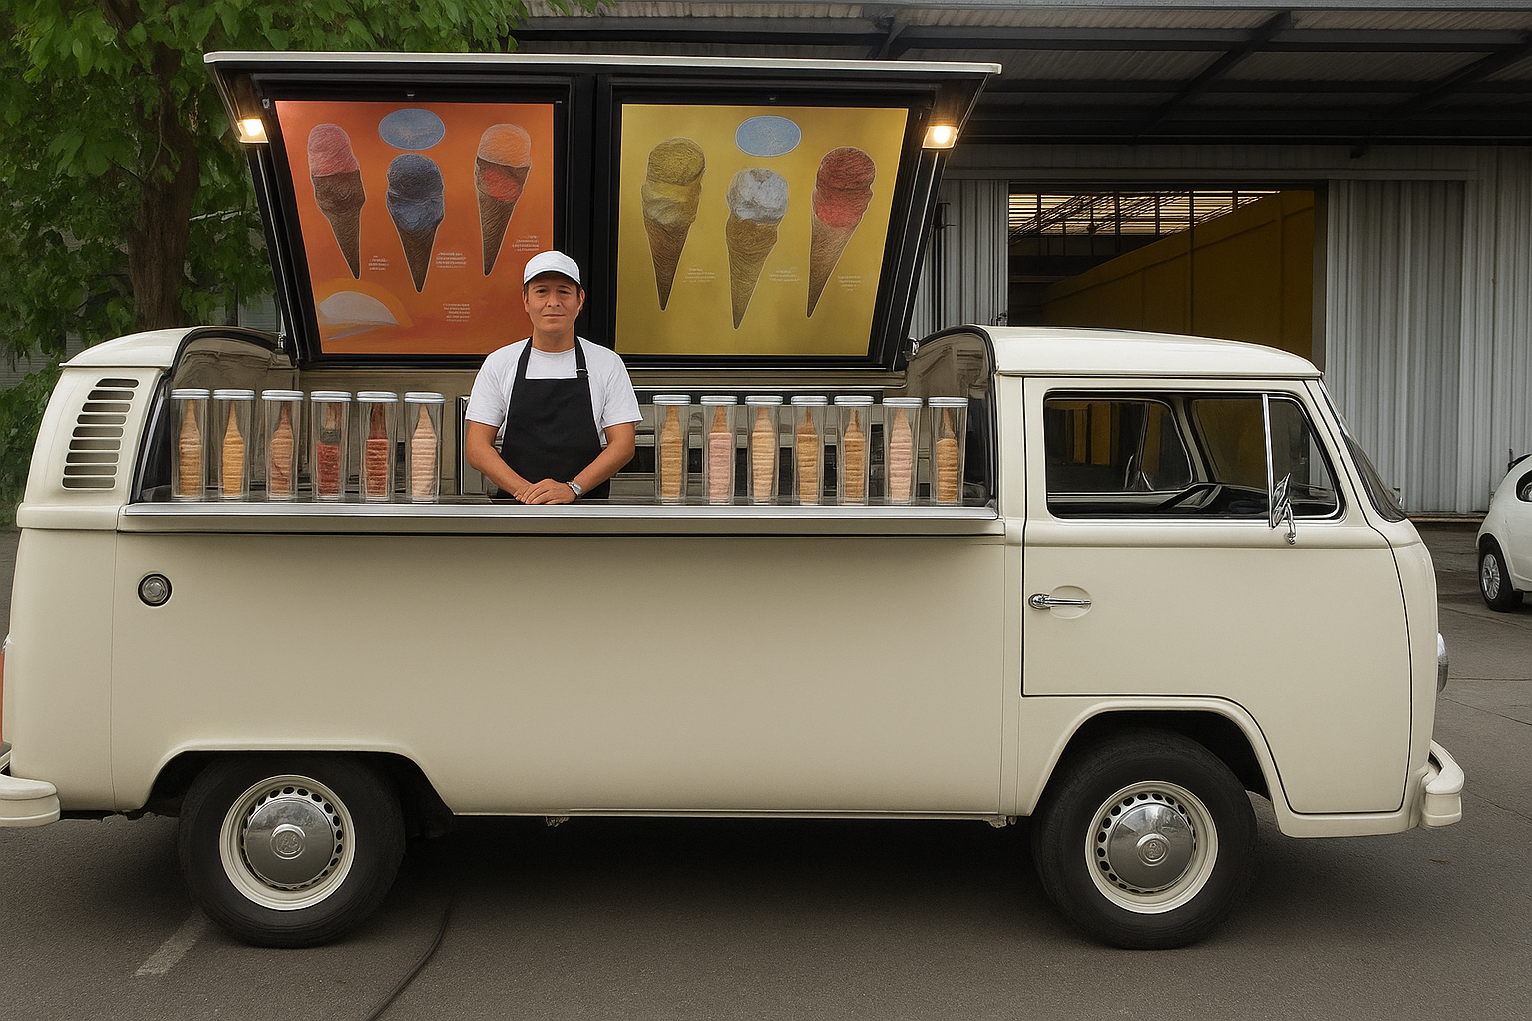

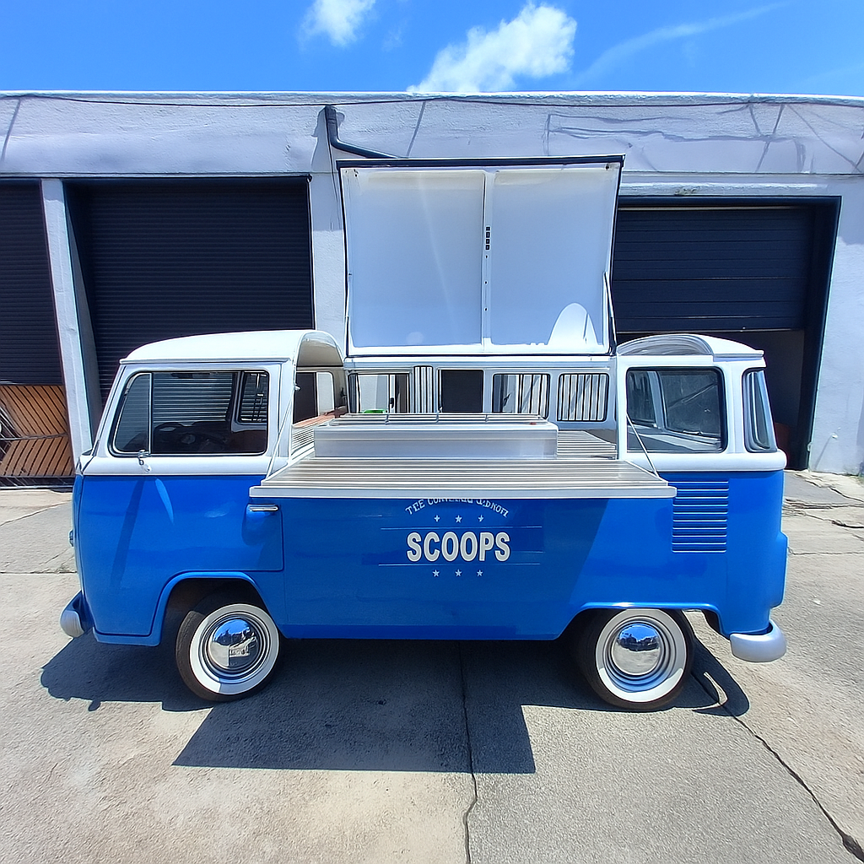

• **Beer Truck** – A draft-on-wheels concept with taps, refrigeration, and a sleek setup for serving cold beers anywhere.

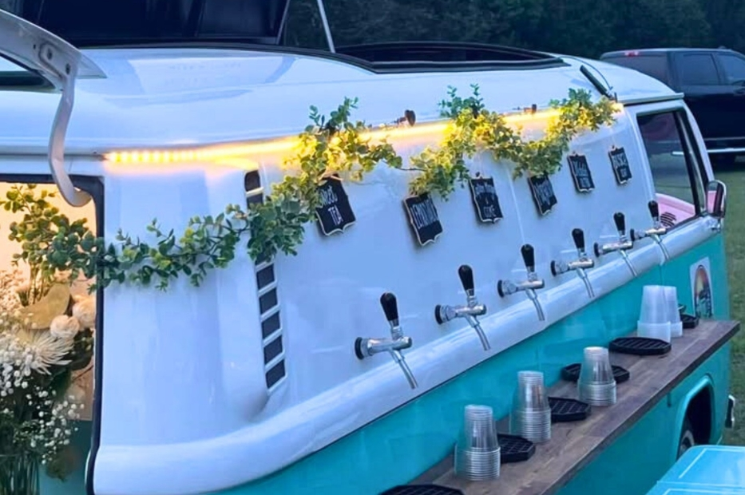

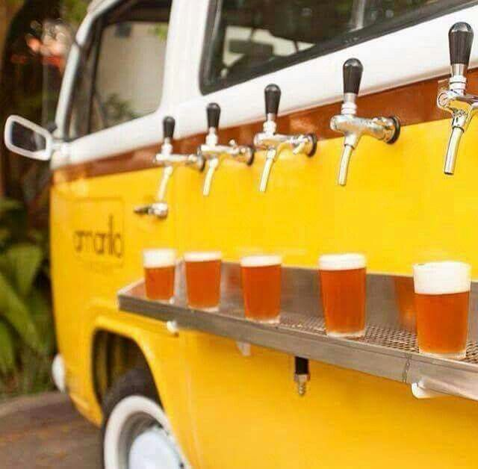

• **Taco/Sandwich/Waffle/Hamburger Truck** – An authentic street-food experience offering freshly made sandwiches or Mexican flavored tacos. For real meat-lovers there is even the option of a gourmet burger kitchen on wheels, grilling up classic and creative burgers with sides.

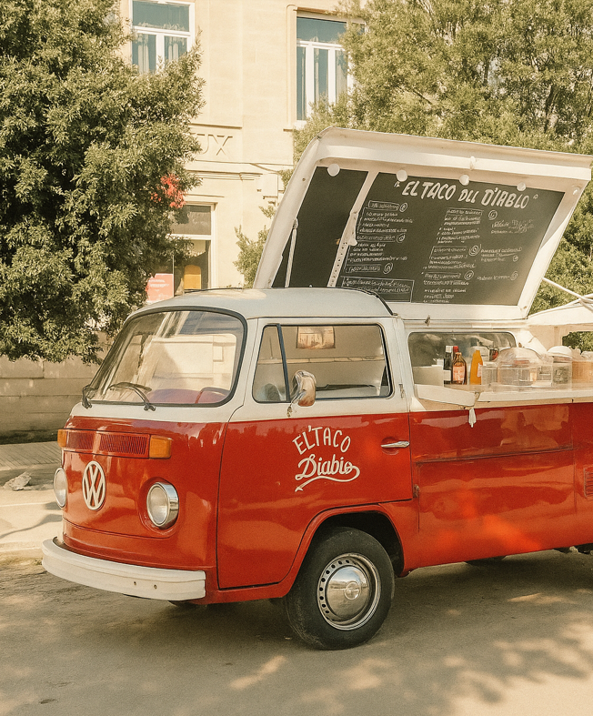

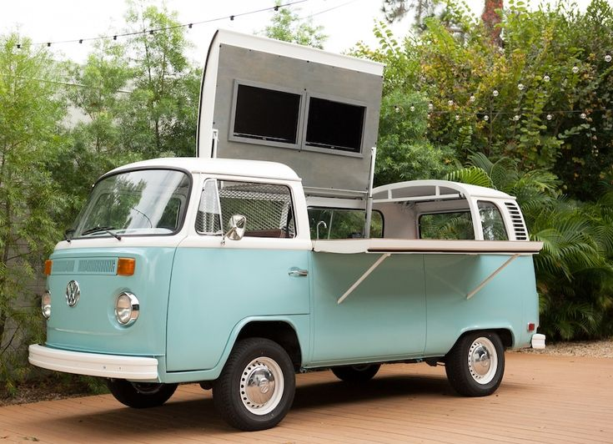

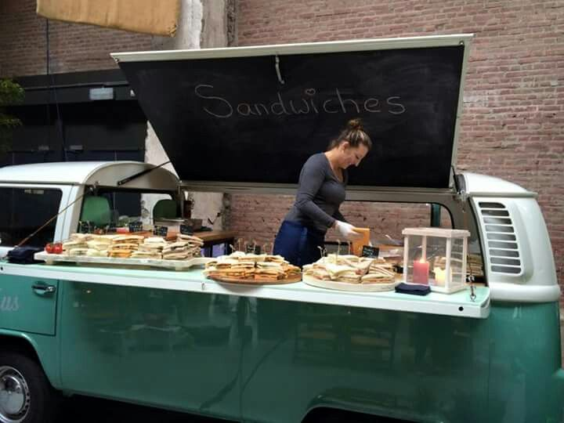

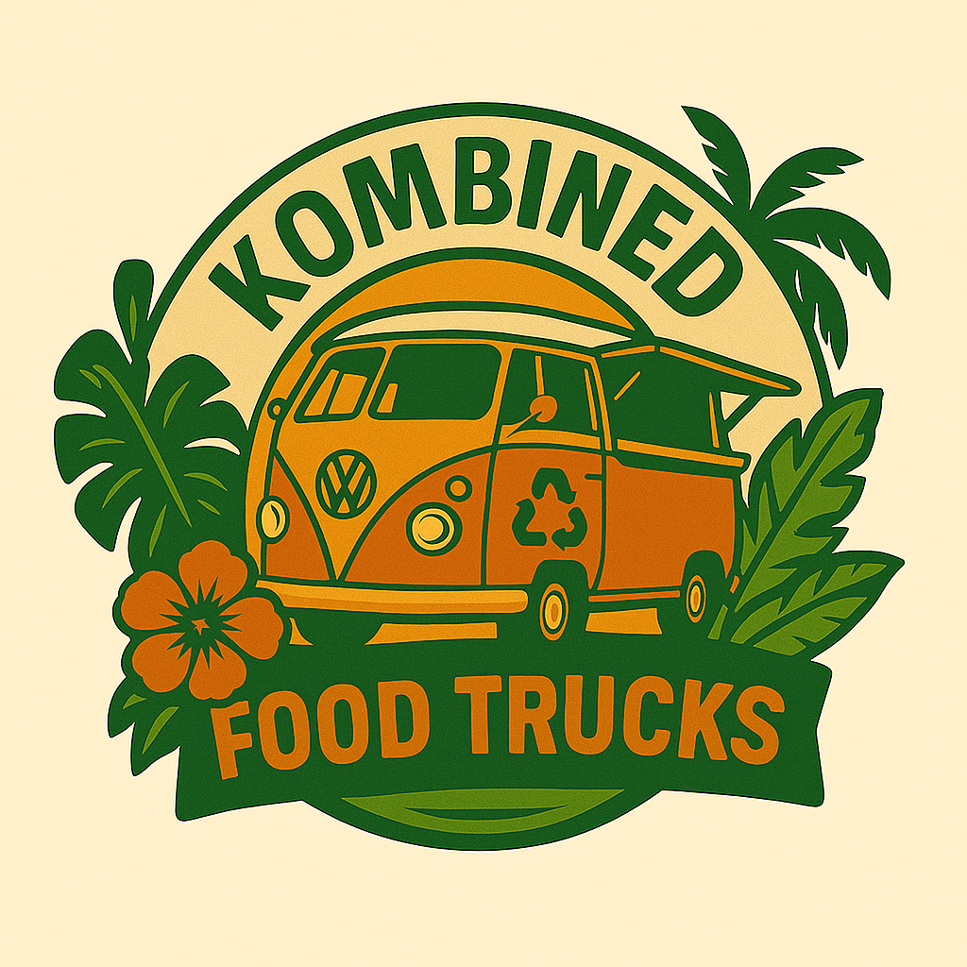

Company Logo

Een paar algemene sfeerimpressies die je kunt gebruiken

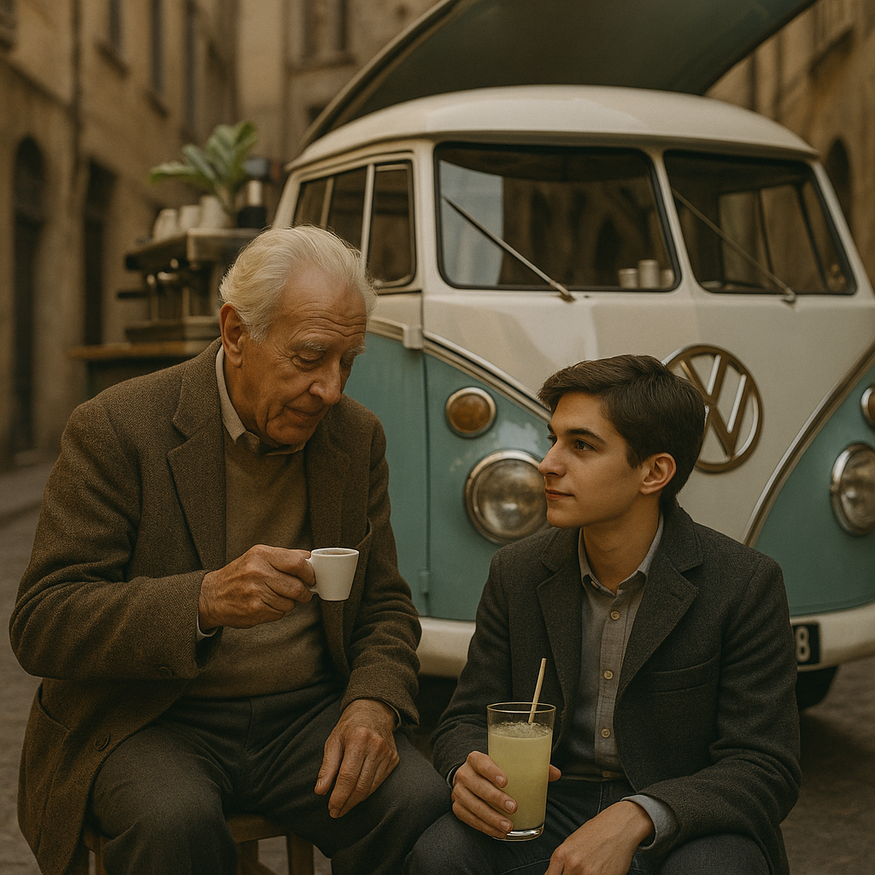

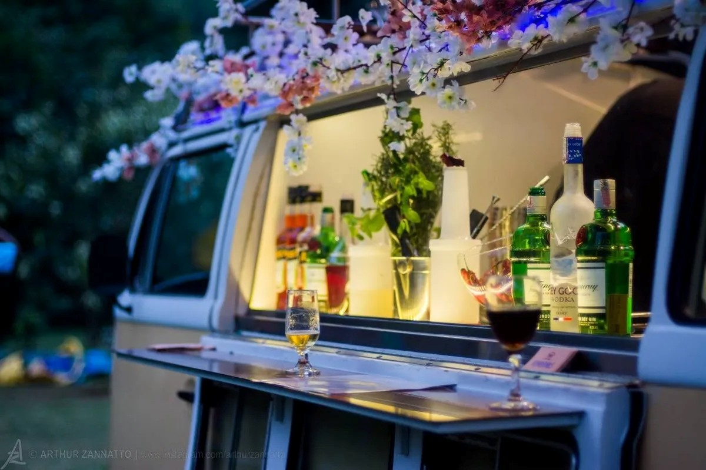

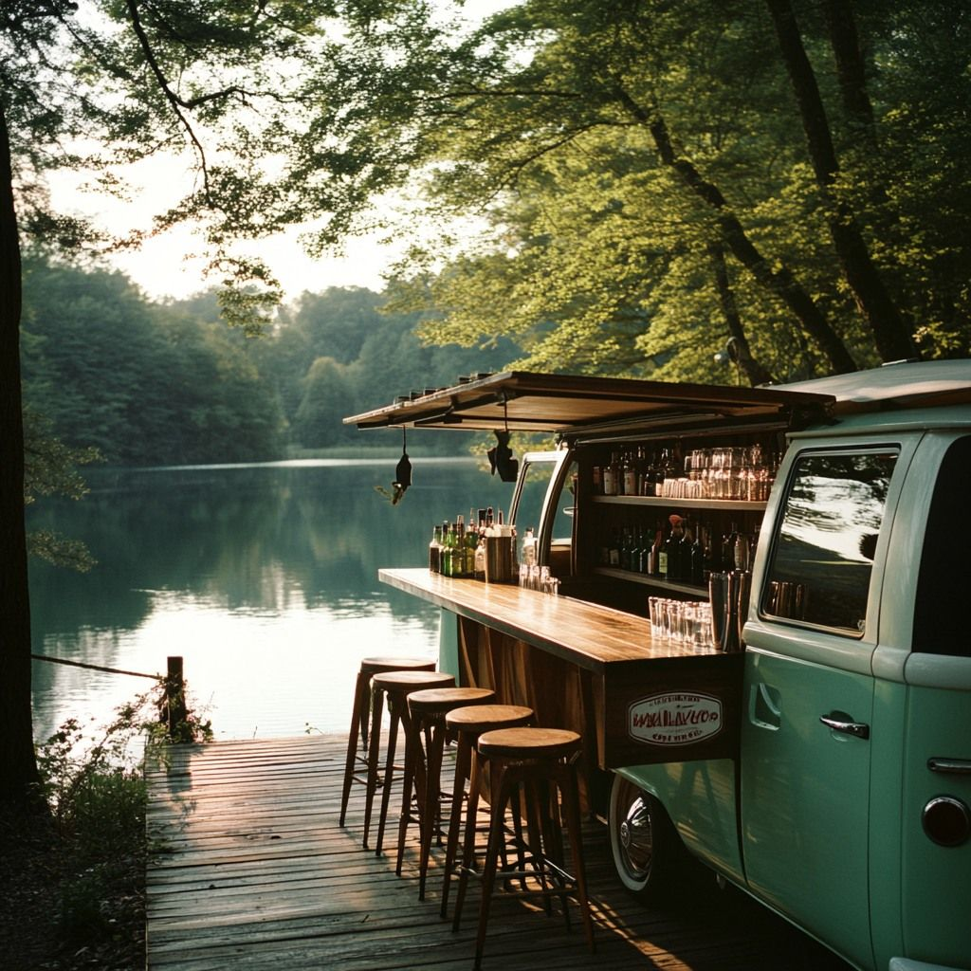

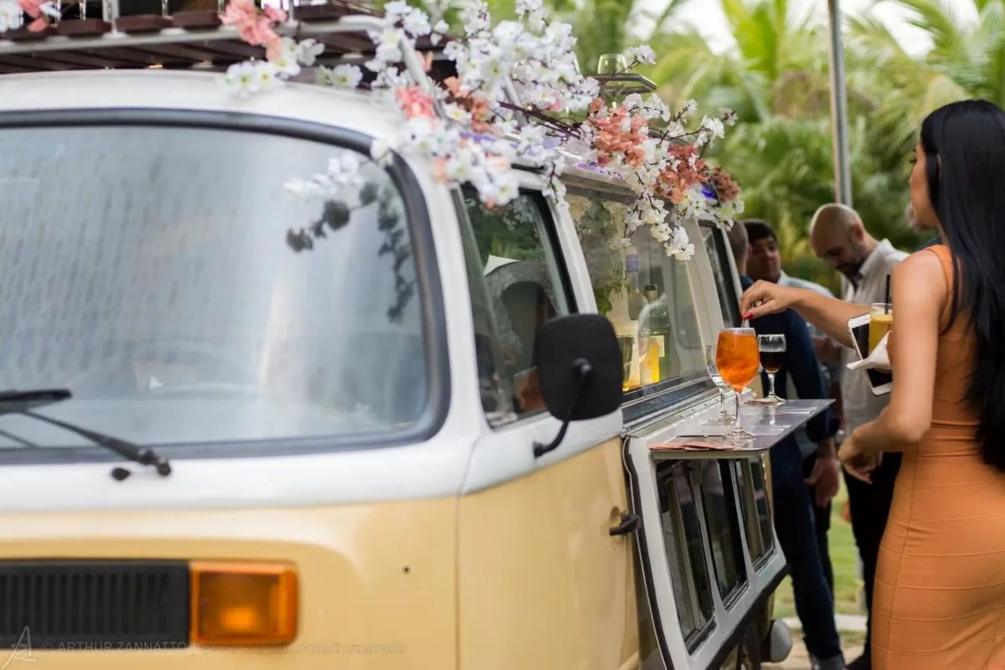

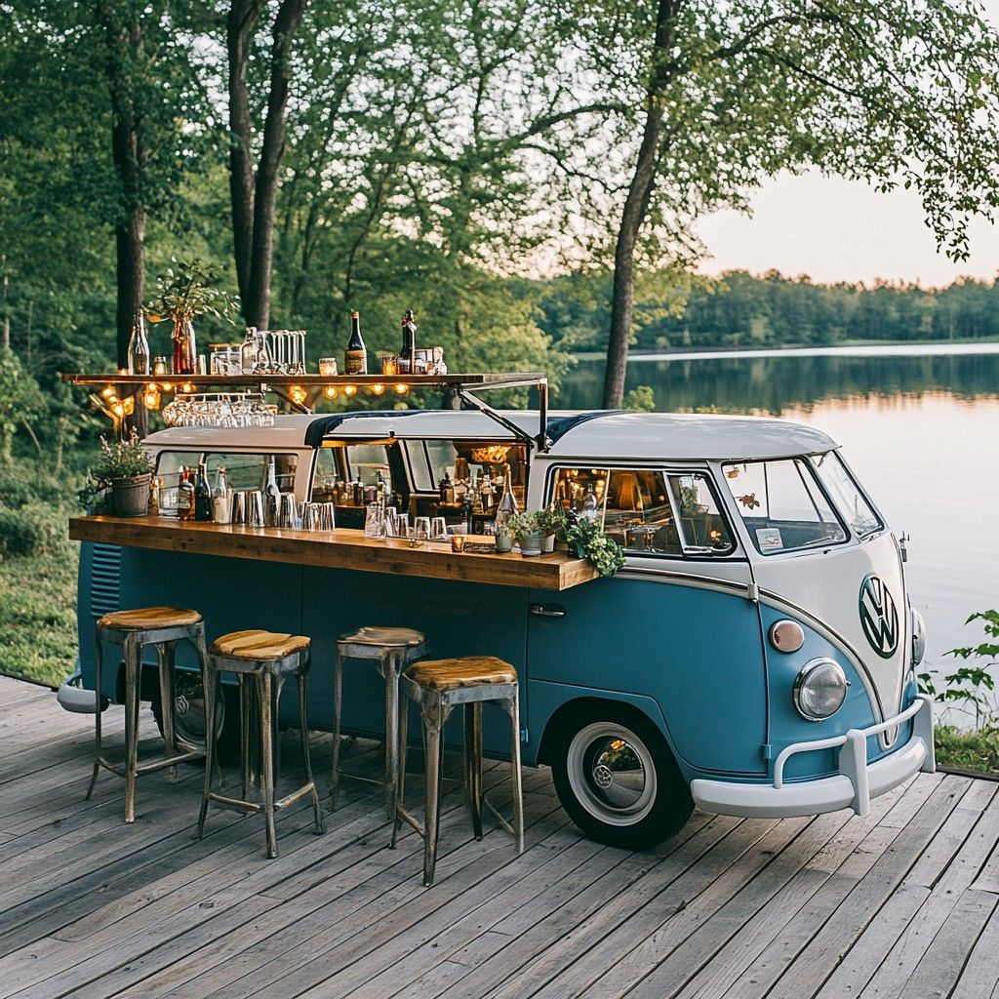

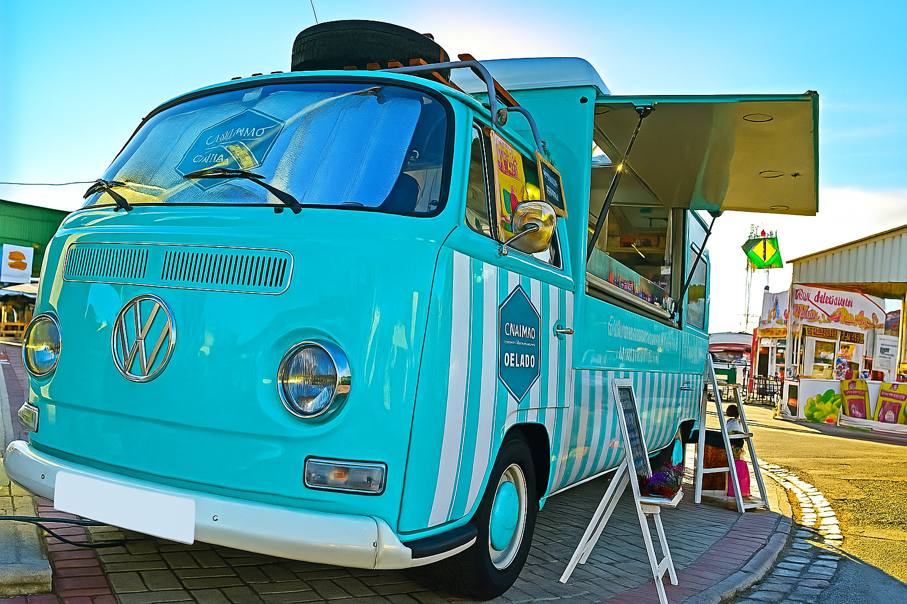

The Volkswagen T1 and T2 aren’t just vans— they’re rolling legends. Few vehicles have captured the spirit of freedom and wanderlust quite like these beauties. Born in the era of the winds of change, they carried the spirit of California dreaming, Tropicalia rhythms, and endless summers of love. Decades later, nothing compares to their charm: the iconic rounded shape, the unmistakable front face, and that timeless vintage aura that turns heads wherever it goes. These vans don’t just transport people — they transport feelings, memories, and stories.

**We give these vans a new life by converting them into food trucks**

When it comes to a food truck, there’s something even more important than nostalgia. Before a single bite is tasted, you need to attract the crowd. In a sea of generic trucks and trailers, a vintage Volkswagen food truck makes you instantly recognizable and unforgettable — a landmark your customers can spot from hundreds of meters away. Our vans do just that. It’s not just a food truck; it’s your stage, your brand, your magnet. The truck guarantees the spotlight. The food? That part is all you.

It might be your first VW Food Truck, but it’s not ours. From coffee to cocktail to flowers, we have a basic plan to get you rolling quicker.

**PRACTICAL ADVICE ON USING A VW BUS FOOD TRUCK**

**DO**

The VW bus food truck is ideally suited to event catering or as a functional piece of decor for your event venue, brand campaign, restaurant, hotel, or mall.

Ideal products to serve from a VW food truck are drinks, coffee, ice cream, sweets, tacos, sandwiches or wraps.

**DON’T**

We do not recommend using a VW bus food truck for serving types of food that require (multiple) fryers, such as fries or fried fish. We do not recommend using a VW bus food truck for charcoal grilling either, unless there is a clear fire security system in place. Ideally, you would use a separate barbecue trailer or larger food truck for this.

**IS A VW BUS FOOD TRUCK RIGHT FOR YOUR BUSINESS?**

We provide a wide range of conversions for elaborate uses, so regardless of what you have in mind we will be able to provide you with an appropriate solution. Let's get started on your custom truck today! Click below to get in touch with.

**For more information about VW bus food trucks or to request a free quote, call us anytime at +31 614633234 or fill out the form on our contact page 🡪 CONTACT US**

**Frequently Asked Questions**

Converting a vintage Volkswagen T1 or T2 into a food truck is an exciting journey, but we know you may have many practical questions before making the leap. Below, we’ve collected answers to the most common questions we receive from our clients in Europe. If your question isn’t listed, don’t hesitate to get in touch — we’re happy to help.

**Can I drive my bus on public roads and do I need a special driver's license?**

Yes, your converted Volkswagen T1 or T2 can be driven on public roads once it is properly registered and insured. In most European countries, you do not need a special driver’s license to drive these vans, as they typically fall under the standard passenger vehicle category (up to 3.5 tons). However, if your van is converted to a larger format and exceeds this weight limit, you may require a different license (such as a C1 license). We always advise you to check the regulations in your specific country.

**Do you also offer VW vans with electric batteries?**

Yes, we do. We currently offer two electric conversion options:

* **Approx. 200 km range**
* **Approx. 250–300 km range**

Electric conversions are significantly more expensive than conventional gasoline setups, but they are a unique way to stand out in the food truck industry. An electric VW food truck positions you firmly in the green, sustainable niche market—an attractive selling point when working with environmentally conscious clients, events, and municipalities. Whether this is the right choice for you depends on your budget, daily travel distances, and the message you want to communicate with your brand.

**How long will it take before my van is ready to be delivered?**

The production time depends on the type of conversion you choose and how elaborate the work is. On average, you can expect a **delivery time of a few months**. A more basic conversion will take less time, while a highly customized or electric build may extend the timeline.

**How much will my vintage VW food truck cost?**

This really depends on your specific needs. Factors that influence pricing include:

* The type of Volkswagen model (T1 or T2)
* The level of conversion and customization
* Decoration and branding requirements
* Choice of engine: gasoline or electric battery

We provide you with a detailed quotation once we understand your exact wishes.

**Is it possible to get a cheaper model?**

To maintain the iconic vibe from the past we decided to work **exclusively with original Volkswagen vans** and not with replicas. Each project begins with an original van — a piece of automotive history — which we carefully refurbish and transform into a fully functional food truck. We believe in giving these classics a new purpose, rather than offering cheap plastic knockoffs that are produced in East Asia and start to crumble at the first sight of rain or frost.

**What warranty do I have?**

Our conversions come with a **two-year warranty on original parts**. Please note that wear-and-tear items such as brakes, tires, or clutches are not covered under warranty, as their lifespan depends on usage. If you decide to convert the engine to an electric battery, the warranty on the batteries also comes with a two-year warranty.

**Will I need to perform a periodic technical inspection?**

Yes. Like any other vehicle in Europe, your food truck will require a **yearly APK (periodic technical inspection)** to remain road-legal.

**What about appliances? How does this work and can I add appliances if I want that?**

Most appliances are fitted with a standard electrical connection, either **220V or 440V**, depending on the product.

If you want appliances installed in your truck, you can choose between **electric or gas-powered equipment**:

* **Electric appliances** will be connected to the truck’s power system.
* **Gas appliances** work with gas bottles, making them ideal if you often operate in locations without (sufficient) electrical supply.

What you need depends strongly on your business concept. We are happy to advise you on the best setup for your operations. You are also free to install your own appliances if you wish, which can help reduce overall costs.

Do you also sell vintage Volkswagen vans without converting them into food trucks?

Yes, we also offer fully restored, high quality VW vans that can be used for transportation or camping.

You can have us source your Volkswagen or if you have found one yourself, bring it to us for renovations. In case you are looking for one, but don’t know how to find or buy one, we can source one for you that meets your requirements and have it renovated according to your desires through one of our partners in various countries across the globe.

**Ready to start your journey?**

A converted Volkswagen T1 or T2 food truck is more than just a vehicle — it’s a statement piece that attracts attention, tells a story, and helps your brand stand out wherever you go. Whether you’re dreaming of a nostalgic gasoline-powered VW or a cutting-edge electric build, we’d love to bring your vision to life.

👉 **Contact us today to discuss your project and receive a personalized quotation.**